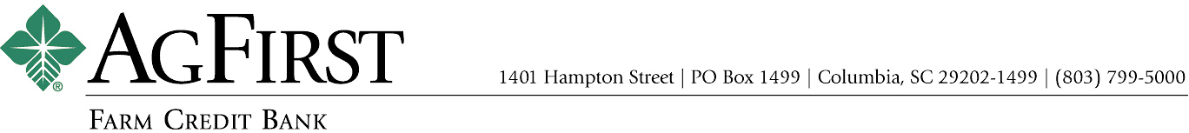

NEWS RELEASE Contacts:
Joy M. Upchurch, Vice President-Marketing
jupchurch@agfirst.com; 803-753-2379
Donna J. Camacho, Director of Communications
dcamacho@agfirst.com; 803-753-2251

for release
Wednesday, February 26, 2003

AgFirst Names Chief Lending and Operations Officer
Columbia, S.C. —AgFirst Farm Credit Bank announced today that William R. Clayton has been named Senior Vice President and Chief Lending and Operations Officer for the bank. With more than 35 years’ experience lending to cooperatives and agribusinesses, he was most recently responsible for managing the lending department at AgFirst. He will assume his new duties on March 17, 2003.
In announcing Clayton’s promotion, AgFirst CEO Andy Lowrey, said, “Bill Clayton’s banking experience uniquely qualifies him to be the leader of these important functions of AgFirst.” Clayton added, “I deem it a privilege to serve an increased role in the delivery of lending and related services to the member associations who own AgFirst and look forward to this new opportunity. My good friend and predecessor, Larry Doyle, leaves a strong team of committed associates at AgFirst and we will strive to continue to deliver excellent value for our stockholders.”
Clayton, 62, is a native of Spartanburg, S.C. He began his career in 1966 as an Agribusiness Specialist for the South Carolina Development Board in Columbia, S.C. He then joined the Columbia Bank for Cooperatives in 1968 where he remained until 1985 when he joined Wells Fargo Ag Credit Corporation in Atlanta, Ga. He returned to the Farm Credit System in 1988, joining CoBank, where he remained until coming to AgFirst in 1998.
Clayton is a graduate of Clemson University and the Graduate School of Banking at L.S.U.

AgFirst names Chief Lending and Operations Officer 2

Clayton will succeed Larry R. Doyle, who was named earlier this week as Chief Executive Officer of the Farm Credit Bank of Texas.
AgFirst provides funding and financial services to 24 farmer-owned financial cooperatives, called Agricultural Credit Associations (ACAs) in 15 eastern states and Puerto Rico. These ACAs provide real estate and production financing to more than 80,000 farmers, agribusinesses and rural homeowners. The bank and its affiliated ACAs reported combined total assets of $15.5 billion as of September 30, 2002.
The Farm Credit System is the largest agricultural lending organization in the United States. On a combined basis, the System reported assets of $107 billion on September 30, 2002, as compared to $101 billion on December 31, 2001. The System’s combined net income for the nine months ended September 30, 2002, was $1.37 billion, as compared to $1.29 billion the same period last year.
###

Note: AgFirst CEO Andy Lowrey is available for interviews. To schedule an interview, please call Donna Camacho, Director of Advertising and Communications, at 803-753-2251, or email her at dcamacho@agfirst.com. Additional information is available at www.agfirst.com.

